Odyssey Rochester Review: Draft 2
Zvi Mowshowitz
Tuesday, January 22, 2002
In the second draft of Pro-Tour San Diego, I was stuck in seat eight. When you're in seat eight, often you have no control over the draft at all. I was amazed by the ability of some people to get through the entire Pro Tour with colors they flat out would not draft, because often a seat will flat out tell you what colors to draft and if you're not ready, the situation will turn ugly pretty fast. In this case, it was clear that there would be blue on both my left and my right but that both red and green would be open before I even got to pick a single card. While Joseph Crosby looked like he might well also be headed into red-green, I wasn't about to accept a worse second color just to stay out of his specific combination. There was no doubt this was a red-green seat.
Table | Seat | Name | Points
1 | 1 | Baberowski, Dirk | 12
 | 2 | Reeves, Neil | 12
 | 3 | Levy, Raphael | 12
 | 4 | Thoren, Jens | 12
 | 5 | Cunningham, Jeff | 12
 | 6 | Crosby, Joseph | 12
 | 7 | Lebedowicz, Osyp | 12
 | 8 | Mowshowitz, Zvi | 12

You get four drafts, and if you blow even one of those, that's all she wrote.
In addition, there was one thing I really liked about this table: There were only three green mages. Baberowski dislikes green, so he avoided it in the first pack, but Reeves declined to pick it up for himself. They still didn't fight, because Neil went into white-red to balance Baberowski's blue-black, but that still left an irregularity in the green drafting. A second one emerged in the middle of the table, where Jens Thoren and Jeff Cunningham, both of whom would end up in the Top 8, went to war over the blue cards. It turns out that this happened because Cunningham was going to draft blue regardless of what his position was, but I'll talk about his choice more when I talk about the Top 8 draft. The result was that me, Crosby and Levy would get to divide the green between us. If I remember correctly, the red was also divided three ways between me, Crosby and Reeves.
If all of that went so right, how come the three of us failed to win a match against any of the other five players? Because that's exactly what happened. You can read about my draft in more detail in my report at www.brainburst.com, but I went 1-2 with my win being against Crosby, and the other two green drafters went 0-2-1 to barely make it into the second day. While I was extremely unlucky to lose in the seventh round, that doesn't change the fact that our overall record was horrible. Looking back at the draft, I definitely disagree with a few of Crosby's individual picks, but he was solid. I can't say I agree with the way Levy drafted, but he didn't seem to be doing anything truly awful and he had a bunch of Wild Mongrels.
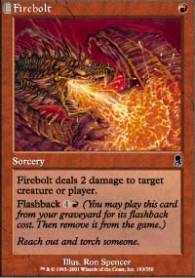
In short, the table simply ended up without its share of green cards, to the extent that even divided among three players none of us had particularly good decks. In my case, it was a problem of synergy and speed, but the only reason my deck was solid to begin with was the three Firebolts and the Squirrel Nest I opened. Take those away and my deck was just poor overall. With the exception of the Nest the deck was based around red cards, and my red position was only fair. All indications would seem to point to my green base being excellent with some solid red support cards. In fifteen of the twenty-four packs, I had the first or second shot at all the green cards, and in many of those where I had second pick I also had second pick of the entire red-green card pool.
The problem here is that Odyssey seems to lack common print runs, at least to the extent that they can be used to predict the distribution of playable cards. In the past it would be rare that a color would be substantially weak or strong over twenty-four packs. That doesn't mean that players wouldn't get into positions and then have the cards not come to them. In Invasion, for example, the multicolored nature of many cards made it very difficult to stick to your colors even when you were in a great position, but if a player was in good position and willing to go into three real colors, it was almost impossible for him to fail to get a solid deck. Now we have players like Jon Finkel spending their drafts first picking multiple Diligent Farmhands for want of anything better.
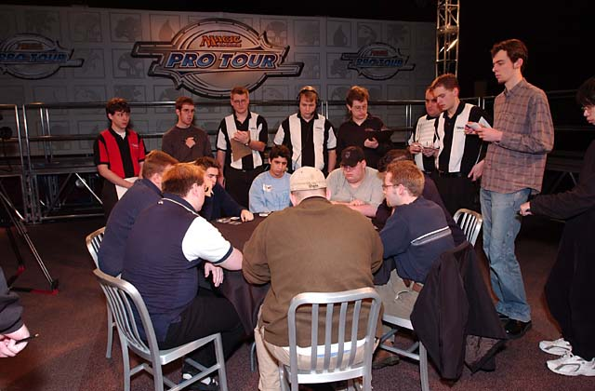
I don't think that any of this changes the overall structure of draft. Position is still extremely important, and it's well worth sacrificing early picks to set up the table. Many other aspects of Odyssey make this strategy highly attractive, and often a player will be well rewarded for it. If anything, its focus has shifted and expanded to include the entire table, because it can be very important to get the third or even fourth best green or blue card out of a pack. Sometimes a pack can even have four or more excellent cards of one of the less deep colors, and sometimes packs will be completely missing one or two colors of cards. In the long run, positioning will pay off. Unfortunately, the long run is not something that will always have a chance to come into play in Magic, because to win you have to win big. You get four drafts, and if you blow even one of those, that's all she wrote. If you succeed, you play a fifth one for most of the marbles. If you fail, it's time to go home and plan for next time.
The only thing a player can do is adjust. The easiest part of the draft is the period after you know what archetype you want to draft, but before the end is in sight. At this point, the challenge is mostly just to take the best card, figure out how to get cards back later in the pack and get along with those around you. Evaluating cards is always tough, but that work has already been done in numerous practice drafts. Later on, the draft takes on a unique quality. What does this deck have too much of and what is still missing? Is there something potentially abusive or combolicious? What are the problem cards or decks out there to deal with? What needs to be done to fix the mana curve? I generally have my deck constructed by the end of pack two, sliding the new cards in and the old cards I no longer have to use out at the end of every pack. The more I draft a format, the more willing I am to throw my own rules out the window at a moment's notice to account for the unique situation at hand, and the faster I'm willing to start doing it. Knowing the rules and having your own is the sign of a good drafter, but knowing when to break them is the sign of a great one.
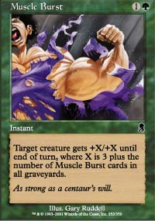
In this particular case, I was drafting red-green. As most people know, the best way to draft red-green is to be aggressive. The priority is in coming blazing out of the gate with fast powerful creatures and backing them up with pump and burn. If there's one mistake I think people make, it's looking for traditionally 'good' cards like expensive creatures and all sorts of burn spells instead of focusing on getting the creatures this kind of deck wants most. Firebolt is amazing, but Flame Burst is only mediocre. Thermal Blast was made for red-black and red-white, not for red-green. Rabid Elephant is great because it's nearly impossible to block, but it's all about Ember Beast and Wild Mongrel. While there are a few people who take cards like Reckless Charge a little too early, especially considering that there is a limit to how many of those you can use unless the deck gets really fast, most people are too willing to compromise the speed of the deck for card quality. Another thing I'm seeing is a strange dislike of Muscle Burst from a lot of players, and that I just don't understand. Give me the choice of between Muscle and Flame Bursts and I'll take a Muscle Burst every time.
In this particular case, I knew I had a huge problem with my creature base but couldn't seem to find any way to fully fix it. Here's the decklist I ended up with:
Zvi Mowshowitz
Draft 2, Pro Tour - New Orleans
Main Deck |  | Sideboard
8 Forest  9 Mountain  1 Lithatog  1 Anarchist  2 Ember Beast  2 Halberdier  1 Cartographer  2 Rabid Elephant  1 Springing Tiger  1 Werebear  1 Wild Mongrel | 1 Blazing Salvo  3 Firebolt  1 Flame Burst  2 Reckless Charge  1 Scorching Missile  1 Thermal Blast  1 Squirrel Nest  1 Still Life | 1 Cephalid Coliseum  1 Angelic Wall  1 Confessor  1 Skull Fracture  1 Acceptable Losses  1 Dwarven Grunt  1 Earth Rift  1 Kamahl's Desire  2 Magma Vein  1 Need for Speed  1 Price of Glory  1 Rites of Initiation  1 Scorching Missile  1 Druid Lyrist  1 Druid's Call  2 Moment's Peace  1 Nimble Mongoose  1 Primal Frenzy  1 Squirrel Mob  1 Terravore

The first thing worth noting is that there was basically nothing left in my sideboard. I could have maindecked Moment's Peace, but I only wanted it against the other red-green player. I could have run Acceptable Losses, but I find those unacceptable most of the time. I strongly considered running Squirrel Mob or Druid Lyrist. In the end, I decided to fill my 'bad card' slot with one Scorching Missile, since I had a bunch of other burn. I also wasn't happy about Thermal Blast.
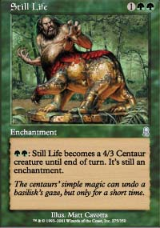
By the middle of the draft, I knew that I was desperate for good attackers. If nothing else, the fact that I played Cartographer without much thought proves that. The only reason I got my Ember Beasts and Rabid Elephants was that others passed them up in situations I would taken them. It was great to have the Beasts, but that meant that it was even more important to find something else to attack along side them. Halberdier isn't generally something I want making the cut in red-green, but it's one of those cards that will get the job done if it has to and it's great with Reckless Charge. There are often cards like Halberdier that are overcosted slightly and aren't really right for the deck, but that are still highly annoying when played and will often get the job done. A top red-green deck will have the card in its sideboard, but there's little harm in running them. Still Life is another card that isn't what I was looking for but normally gets the job done. Time and board control are very important to red-green, and Still Life works against both of those while looking very silly next to Reckless Charge. Regardless, I had very little choice - I couldn't draft the Seton's Desire it was up against because I had nothing to put it on, and I needed that 4-power desperately.
Often a color combination will have an ideal deck a player can strive for - sometimes called 'the' red-green deck or similar - and then have a more standard version that uses more mainstream cards. Trying for the specialized deck is very rewarding but it is also risky. If you commit to the faster version and the cards don't come, the resulting deck will be a mess. If you stay on the fence and draft a more traditional deck, then you don't get maximum use out of some cards but the draft remains flexible and won't be a disaster if the cards are less than ideal. I beat myself up right after the draft for failing to try for 'the' red-green deck, but looking back now I think the opposite. I tried to draft the deck, and it didn't come, leaving me with elements from that deck I had no choice but to play despite the fact that the rest of the deck wasn't there. It definitely hurt. However, the cards for red-green in general didn't come either, and I didn't really have alternative picks for most of the problematic cards.

